Interface LayoutEditor

The effectiveness of the directly depends on the tools that we use. But even the most powerful tool will not help if they did not know how or misused. In this regard, an interesting pattern, the more money provides a tool, so it is more difficult. From this situation there are two exits, the first - to create a simple and intuitive interface, which is an art and a second - writing detailed documentation. Well, in this paper I will go the second way and tell you the main points of using a tool that allows you to create user interfaces (forms). So start LayoutEditor…

Key Terms and Their Meanings

- Widget - (control) the general name of the element from which the forms are made.
- Form - (layout), the hierarchy of widgets, usually with one main widget in the bud.
- Skin - (Hide) the combination of features and visual elements that determine how the widget looks like.

The Main Panel and Controls
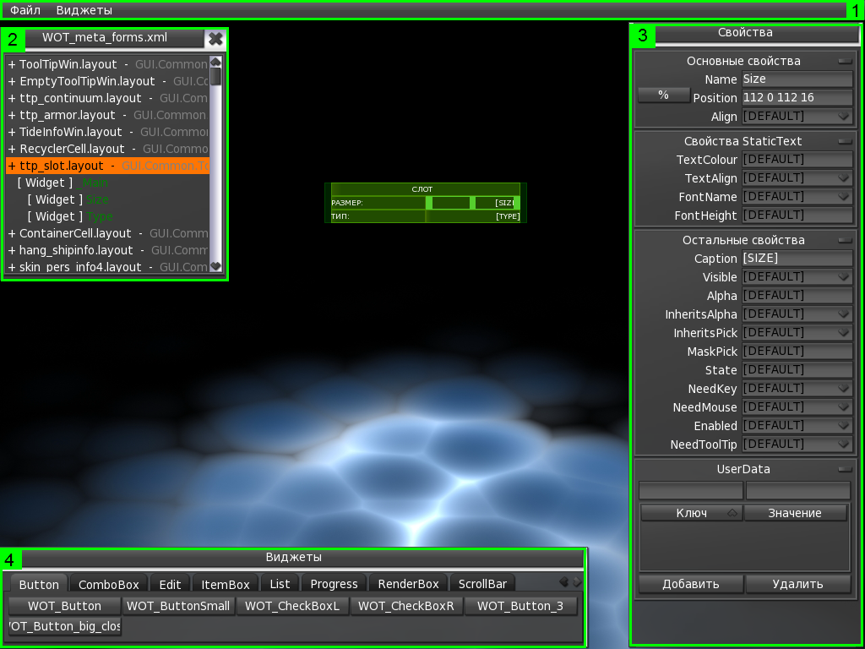

As we can see, the space editor, basically, consists of panels and menus. Some panels may be missing, some may appear when needed. It is also possible mode when the panel, with a loss of focus, I stop at the edge of the editor. All the rest of the space available for editing and can contain arbitrary widgets and forms.

Menu (1)

The menu is a classic option, if enabled AutoHide, the menu is cleaned up. In the menu there are two main sections:
- File - basic settings and commands
- Widgets - the hierarchy of widgets created

Section of the menu “File”

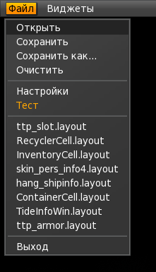

Commands are grouped in the following order:
- The commands for opening, saving and clean forms.
- Configure and test mode shapes created
- List of recent downloaded forms
- Exit

When you save and open dialog is displayed with a choice of file. There is also an opportunity to drag the file into the editor directly from Explorer.

If you select the settings, open the window in which the available basic configuration editor.

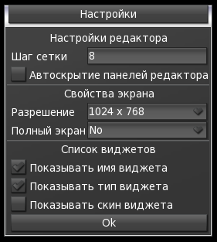

In the first group, you can specify the grid spacing, which “sticks” frame creation and allocation of the widget that lets you move widgets, and change their size is not fit to pixel by pixel, which is very easy to get wrong. Also present check to activate AutoHide panels, while the mode, the panels go over the edge of the screen, leaving a small corner of the panel when the mouse leaves the panel on which all the way back and become available.
In the second group settings screen.
In the third group set up necessary properties widget, which should be shown in the hierarchy. In the hierarchy itself, which is available in the second section of the menu “widgets.” (See below)

Section Menu “Widgets”
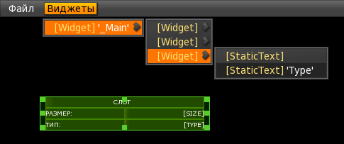

This section shows the hierarchy of created widgets, the widget by clicking on the menu, the widget is allocated in an appropriate manner. This organization is more intuitive and easy to navigate and also lets you know the basic parameters of the widget, such as type, name, and skin. (Optional, configurable in the settings)

Solution (2)

Solution is a panel that displays the form of projects. The panel is optional, it appears, if you drag a file into the editor solyushen. Also, it can always be close. File solyushen generated utilities, or by hand. It is a meta-description forms, which are expected in the project, in the form prescribed types of widgets and their names. Also in solyushene optional can describe the available skins, and skins to create a default.

For example the following meta-description:

<MetaForm desc="GUI.Common.ToolTips.ContainerItemParts.QuestItem"layout="ttp_questItem.layout">
<MetaWidget name="_Main" type="Widget">
<MetaWidget name="Name" type="Widget" />
<MetaWidget name="Quest" type="Widget" />
<MetaWidget name="Desc" type="Widget" />
</MetaWidget>
</MetaForm>

Will be the following:
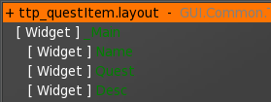

If you are using windows solyushen need to understand that this kind of clue, which says that you need to create, what type should have a widget and what name, everything else depends on the developer’s form. Consider the following example:

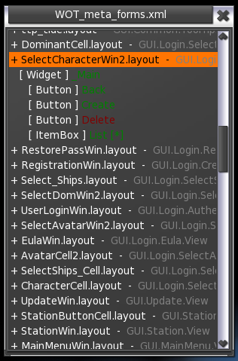

When you double-click on the name of the form, it takes place, and before us presents a list of all the necessary widgets for this form. It is also clear that in this example, there is a certain hierarchy. ie Requires a widget with the name «_Main» and is already on it will be attended by all the other widgets. But it does not impose additional restrictions on widgets, ie For example, the button «Back» can be on any widget or widgets that will create a user (decorative panels or pictures). The list indicates the type of widget, which is expected, and name. The name can have different colors, depending on how established it at the moment or not, for example, is marked in red widget, which has not yet created (in the example «Delete») and the green one that is already present.
With single-click on the name of the widget, it is allocated in the form, if created, double-, is created if it does not yet exist. When you create using the default skin and default size and is created on the currently selected widget.
After the name of the widget, can we sign [*] (In the example «List [*]»), this means that the widget is not finite, and it hosts another form. For example ItemBox may contain cells, which are another form. Double-clicking on this widget gives you a form to be affiliated to this widget. But the user is not a complicated task, because the additional action is required, still need to create a widget with the type and name.

Property (3)

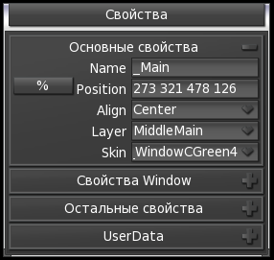

The properties window appears only if you selected any widget as well, the panel supports AutoHide. The panel is acceptable to change the size, for a more convenient location. In this panel available properties that apply to the current widget, as well as additional data. The panel is a context, ie there may be missing some of the section or sections within certain parameters.
Also note that the input data, if they are logically wrong, I change the color to red (or another depending on the topic). Some properties have a certain set of values, and it is possible to select the desired. Some properties require immediate user input.
Section, you can manually turn off, it is necessary to click on the button in the form minus the right of the section after this section will be curtailed, and the button will take the form of a plus for the disclosure section must click on the “plus”.

The main properties:

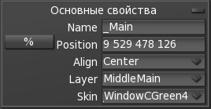

Section, which contains properties that apply to any widget - the name, position, alignment, and skin. Property «Layer» is not mandatory, and is usually present at the main widget of the form. This property determines which logical layer, you must attach a widget. Property «Position» has an additional switch that allows you to specify the position and size in pixels, not only, but also as a percentage of his father.
The remaining properties:

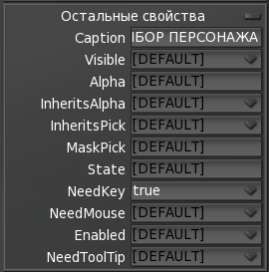

Section, which contains properties that are present in all widgets. Of the main header, visibility, transparency, prompt, support for mouse and keyboard.

The properties of a particular type of

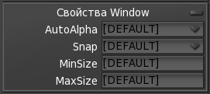

This section is adjusted to the particular type of widget (in the example Window), and displays only the properties. The section may be missing if the properties do not.

The user data

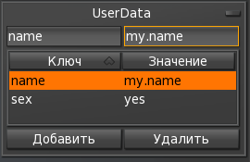

This section allows you to associate arbitrary data with the widget in your code to access them. Access is by key value.

Widgets (4)

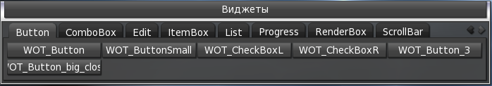

The window widget is a tab that contains all of the available skins that can be used. The grouping of tabs is arbitrary, and is available through xml configuration, but with a large number of skins, it is more convenient to have each tab has a type, and it contained the skins to be used for this type. When you hover over a button skin, prompted, in which it is possible to see the look of the widget, without its inception. Just a tip size is specified, for which the widget is created, this is usually the recommended size if the widget is not intended to stretch.

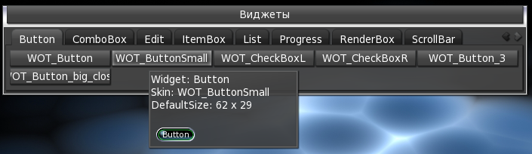

To create a widget, you must select the skin by clicking on its button, this button is pressed. Next, in the right place, or form window, click the left mouse button and holding it down, stretch the widget to fit your needs. In the future, the size can be changed through the properties panel, or directly dragging a marquee widget. To remove a widget you can press the button «Delete» key on your keyboard.

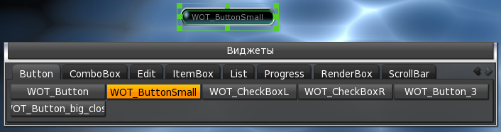

Additional information

Select and move

The currently selected widget is framed by a special frame, which allows you to change its size. It is also a dedicated widget can be moved by clicking and pulling it in any place.

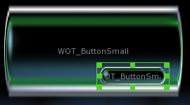

To change the position or size without reference to the grid, press and hold the «Shift» with the size or position will be changed pixel by pixel.

